

TRIBHUVAN UNIVERSITY
Faculty of Humanities and Social Science

Electronics Store(E-Commerce)

A Project Report Submitted To:
Department Of Computer Application Samriddhi College

In partial fulfilment of the requirements for the Bachelor of Computer Application

Submitted By:

Suraj Dahal

Samir Dahal

Under the Supervision of
Mr. Bikash Balami

TRIBHUVAN UNIVERSITY
Faculty of Humanities and Social Science Samriddhi College

Supervisor’s Recommendation

I hereby recommend that this project prepared under my supervision by Suraj Dahal and Samir Dahal entitled “Electronics Store” in partial fulfillment of the requirements for the degree of Bachelor of Computer Application is recommended for the final evaluation.

Bikash Balami
SUPERVISOR
Lecturer
Samriddhi College
Lokanthali, Bhaktapur

TRIBHUVAN UNIVERSITY
Faculty of Humanities and Social Science Samriddhi College

LETTER OF APPROVAL

This is to certify that this project prepared by Suraj Dajal and Samir Dahal entitled “Electronics Store” in partial fulfillment of the requirements for the degree of Bachelor in Computer Application has been evaluated. In our opinion it is satisfactory in the scope and quality as a project for the required degree.

SIGNATURE of Supervisor | SIGNATURE of HOD/ Coordinator
SIGNATURE of Internal Examiner | SIGNATURE of External Examiner

Abstract

The Electronics Store E-Commerce Project is a web-based application designed to provide customers with a seamless online shopping experience for electronic products. The platform enables users to browse, search, and purchase a wide range of electronics such as smartphones, laptops, home appliances, and accessories. Developed using modern web technologies, the system incorporates features like product categorization, detailed descriptions, price filtering, and a secure shopping cart with online payment integration. An intuitive user interface ensures easy navigation, while an admin panel allows store managers to manage inventory, update product details, and process orders efficiently. By combining user-friendly design with robust backend functionality, this project aims to enhance customer convenience, expand market reach, and streamline sales operations for the electronics store.

This project is an online electronics store designed to simplify the process of buying and selling electronic products. It includes features like product browsing, advanced search, a shopping cart, order tracking, and secure online payments. The admin module allows efficient inventory and order management. With its responsive design and robust backend, the system delivers a smooth shopping experience for customers while supporting the operational needs of the business.

Acknowledgement

This project would not have been possible without the help and guidance of many individuals despite the huge efforts from my side. I would like to extend my sincere thanks to all. I am indebted to Samriddhi College and its members for the support and supervision and also for providing the necessary information regarding this project.

Also, We would like to thank my project guide Mr. Snajivan Satyal for his kind co-operation and guidance which has helped me in the completion of the project. I give my special thanks and kind appreciation to my seniors, colleagues, and a few individuals for their help during my project.

Thanks,
Suraj Dahal
Samir Dahal
BCA 6th Semester

Table of Contents

Chapter 1: Introduction 1
  - Introduction 1
  - Problem Statement 2
  - Objectives 2
  - Scope and Limitations 3
  - Development Methodology 4
Chapter 2: Background Study and Literature Review 5
  - Background Study 5
  - 5Literature Review 6
2.3. Existing Systems 7
Chapter 3: System Analysis and Design 8
  - System Analysis 8
    - Requirement Analysis 8
      - Functional requirements 8
      - Non-functional requirements 9
    - Feasibility Study 10
      - Economical 10
      - Operational 10
      - Technical 10
      - Schedule 11
    - Data Modelling 12
    - Process Modelling (DFDs) 12
  - System Design 15
    - Architectural Design 15
    - Database Schema Design 16
    - Interface Design 17
3.3. Algorithm Details…………………………………………………………………….19

Chapter 4: Conclusion and Future Recommendations 20
4.1 Conclusion 20
4.2 Future Recommendations 20
References 21

List of Figures
Figure 1. 1 Agile model .......................................................................................................4
Figure 3. 1 Use Case Diagram of Electronics Store........................................................... 9
Figure 3. 2 ER Diagram of Electronics Store. ................................................................ 12
Figure 3. 3 Level 0 DFD of Electronics Store................................................................. 13
Figure 3. 4 Level 1 DFD of Electronics Store...................…..........................................13
Figure 3. 5 Level 2 DFD of Electronics Store.....................................................…........ 14
Figure 3. 6 Architectural design of Electronics Store...................................................... 15
Figure 3. 7 Database Schema Design ................................................................................ 16
Figure 3. 8 User Login ..........................………………..................................................... 17
Figure 3. 9 Admin Login ............................................………………................................ 17
Figure 3. 10 Register of user .............................................................................................. 18

List of Abbreviations
ER | Entity-Relationship
HTML | Hypertext Markup Language
CSS | Cascading Style Sheet
RAM | Read Only Memory
DFD | Data Flow Diagram
MySQL | My Structured Query Language
UI | User Interface
PHP | Hypertext Preprocessor

Chapter 1: Introduction

Introduction

In today’s digital era, e-commerce has transformed the way people shop, making products and services accessible anytime and anywhere. The Electronics Store E-Commerce Project is designed to provide a complete online platform for selling electronic products such as smartphones, laptops, accessories, and home appliances. This system enables customers to explore a wide variety of products, compare prices, read detailed specifications, and place orders securely from the comfort of their homes.

The platform integrates essential e-commerce features including product categorization, search filters, shopping cart functionality, order tracking, and secure payment gateways. A dedicated admin panel allows store owners to manage product listings, update stock availability, monitor sales, and process orders efficiently.

Developed using modern web technologies, the system ensures a responsive and user-friendly interface across devices, providing an optimal shopping experience. By implementing this project, the electronics store can extend its market reach, improve customer convenience, and streamline sales operations, thus enhancing overall business growth.

Problem Statement

Traditional electronics retail stores face several limitations, including restricted geographical reach, limited operating hours, and dependency on in-person customer visits. Customers often encounter difficulties such as lack of detailed product information, limited options for comparing products, and time-consuming purchasing processes. On the business side, store owners struggle with managing inventory efficiently, tracking sales data, and responding quickly to customer demands.

Following points would more clarify about the problem statements:

- Limited geographical reach of physical electronics stores restricts potential customer base.
- Customers face difficulty comparing products and prices in traditional retail settings.
- Lack of 24/7 accessibility reduces convenience for buyers.
- Inadequate product information in physical stores limits informed decision-making.
- Manual inventory management can lead to errors and stock mismanagement.
- Tracking sales and customer trends is time-consuming without digital tools.
- Growing demand for a secure and user-friendly online shopping experience for electronics.

Objectives

- To develop a user-friendly e-commerce platform for purchasing electronic products online.
- To provide detailed product descriptions, specifications, and images for informed buying decisions.
- To implement product categorization and search filters for quick and easy navigation.
- To integrate a secure shopping cart and payment gateway for safe transactions.
- To design a responsive interface compatible with desktop, tablet, and mobile devices.

Scope and Limitations

Scope:
- The system allows customers to browse, search, and purchase electronic products online.
- Provides detailed specifications, images, and pricing for each product.
- Includes shopping cart, checkout, and secure payment gateway integration.
- Offers account creation and login for personalized shopping experiences.
- Enables order tracking and email/SMS notifications for purchase updates.
- Admin panel for managing inventory, updating products, and processing orders.

Limitations:

- Requires a stable internet connection to access the platform.
- Payment gateway integration depends on third-party service providers.
- Does not cover physical delivery logistics; relies on external courier services.
- Limited to managing electronic products only (no multi-category retail support initially).

Development Methodology

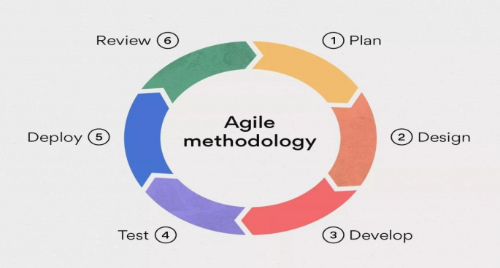
Figure 1.1 Agile Model
This project is developed using the Agile methodology, which is an iterative and incremental approach to software development. The project is divided into small modules called sprints, each delivering a functional part of the system. Features such as user registration, product catalog, shopping cart, checkout, and admin panel are implemented in separate sprints.

Chapter 2: BACKGROUND STUDY AND LITERATURE REVIEW

2.1. Background Study

The rapid growth of internet usage and digital technologies has transformed the way businesses operate, with e-commerce emerging as one of the most significant developments in recent years. Electronics retail, in particular, has experienced a shift from traditional brick-and-mortar stores to online platforms, driven by factors such as convenience, competitive pricing, and access to a wider product range.
In traditional electronics retail, customers are limited by geographical location, store timings, and stock availability. These limitations often result in reduced customer satisfaction and lost sales opportunities. On the other hand, e-commerce platforms enable customers to shop anytime, from anywhere, while providing features like detailed product information, price comparison, and customer reviews.
Globally, companies such as Amazon, Best Buy, and Flipkart have set high standards for online electronics shopping by offering fast delivery, flexible payment options, and user-friendly interfaces. However, many small to medium-sized electronics retailers still lack the resources to develop fully functional e-commerce systems tailored to their needs.
This project aims to bridge that gap by creating a cost-effective, scalable, and secure e-commerce platform specifically for electronics retailers. It combines modern web technologies, secure payment systems, and an intuitive user interface to provide a seamless shopping experience for customers while empowering store owners with efficient management tools.

2.2. Literature Review

E-commerce has revolutionized the retail sector by providing customers with the ability to purchase products anytime and anywhere. The adoption of online shopping platforms is largely influenced by perceived usefulness, ease of use, and trust, as outlined in the Technology Acceptance Model. Successful e-commerce platforms are characterized by high system quality, accurate and detailed information, and reliable service quality. In the context of electronics retail, usability and user experience play a significant role, emphasizing the need for simple navigation, error prevention, and responsive interfaces.
Studies on cart abandonment highlight that complex checkout processes, unexpected costs, and limited payment options are major reasons for customers leaving without completing their purchases. To address these issues, platforms should implement guest checkout, clear cost breakdowns, and multiple secure payment methods. Security and privacy are also crucial; for protection of sensitive customer data and build trust. Furthermore, personalization through recommendation systems, as demonstrated collaborative filtering model , has been shown to enhance user engagement and increase sales.
Performance optimization and mobile responsiveness are also essential, as mobile devices now account for a majority of online shopping traffic. Clean and structured product catalogs, effective search functionality, and advanced filtering options improve product discoverability and customer satisfaction.

2.3. Existing System

Currently, many electronics stores operate through traditional brick-and-mortar models or use basic online catalogs with limited functionality. In physical stores, customers must visit the location to browse and purchase products, which restricts accessibility to local buyers and limits sales to store operating hours. Even when a store has an online presence, it is often limited to displaying product listings without integrated features such as a secure shopping cart, online payment processing, or real-time inventory updates.
Some existing e-commerce systems for electronics, like those used by large retailers (e.g., Amazon, Best Buy), offer advanced features such as personalized recommendations, multiple payment methods, and order tracking. However, these systems are expensive to develop and maintain, making them unsuitable for small and medium-sized electronics businesses. In many smaller setups, product details are not updated regularly, stock availability is inaccurate, and customers have to confirm purchases manually via phone or email.
These limitations result in poor customer convenience, delayed transactions, and missed sales opportunities. Moreover, the absence of robust security features in smaller systems increases the risk of payment fraud and data breaches. Therefore, there is a need for a dedicated, affordable, and feature-rich e-commerce platform tailored specifically for electronics stores to overcome the shortcomings of existing systems.

Chapter 3: SYSTEM ANALYSIS AND DESIGN

3.1. System Analysis

System analysis is the process of studying and understanding the existing problem, requirements, and objectives before designing a new system. It involves examining how the current system works, identifying its limitations, and determining what improvements are needed to meet user needs effectively. In the context of the Electronics Store E-Commerce Project, system analysis focuses on understanding both customer and business requirements to develop a platform that enhances the online shopping experience for electronics.

3.1.1. Requirement Analysis
The primary goal of the system is to provide an online platform for purchasing and selling electronic products with secure transactions and efficient management.

Functional Requirement
- User registration and login.
- Product browsing with categories and search filters.
- Detailed product pages with specifications and images.
- Shopping cart and checkout process.
- Secure payment gateway integration.
- Order tracking for customers.
- Admin panel for managing products, inventory, and orders.

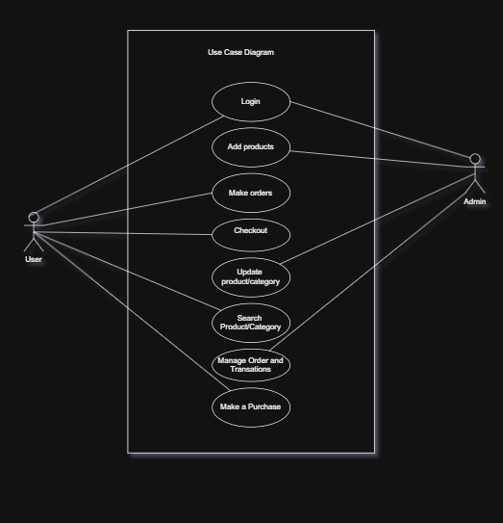

Fig. Use Case Diagram

Non-functional requirement:
Non-functional requirements define how the system performs its functions. these include:

- Responsive and user-friendly interface.
- Secure data storage and transaction handling.
- Scalability for future feature expansion.
- High performance with minimal page load time.

3.1.2. Feasibility Study
Depending on the results of the initial investigation the survey is now expanded to a more detailed feasibility study. “FEASIBILITY STUDY” is a test of system proposal according to its workability, impact of the organization, ability to meet needs and effective use of the resources.

i. Economic Feasibility
Developing this e-commerce platform is cost-effective compared to purchasing commercial solutions or outsourcing. It helps reduce operational costs by automating order management and inventory tracking while increasing sales opportunities through online reach. The investment in development is expected to provide a good return by attracting more customers and streamlining store operations.

ii. Operational Feasibility
The system is designed to be user-friendly, allowing customers to browse products, place orders, and make payments with minimal effort. The admin panel provides straightforward tools for managing products, inventory, and orders. Training requirements for staff are minimal, ensuring smooth adoption of the system.

iii. Technical Feasibility
The system will be developed using widely available web technologies such as PHP, MySQL, HTML, CSS, and JavaScript. These technologies are well-supported, easy to maintain, and suitable for building a responsive and secure e-commerce platform. The existing hardware and software infrastructure of the store is sufficient to support the system.

iv. Schedule Feasibility
Time evaluation is the most important consideration in the development of project. The time
schedule required for the developed of this project is very important since more development
time effect machine time, cost and cause delay in the development of other systems.

Project Schedule
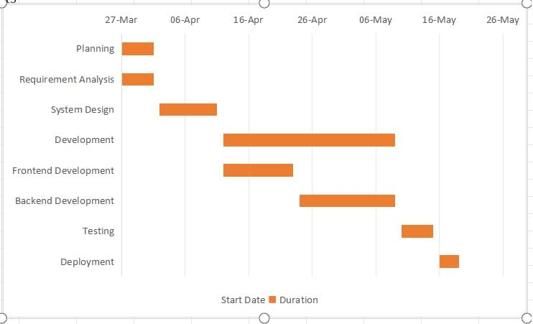

Fig. Project Schedule

3.1.3. Data Modeling (ER-Diagram)

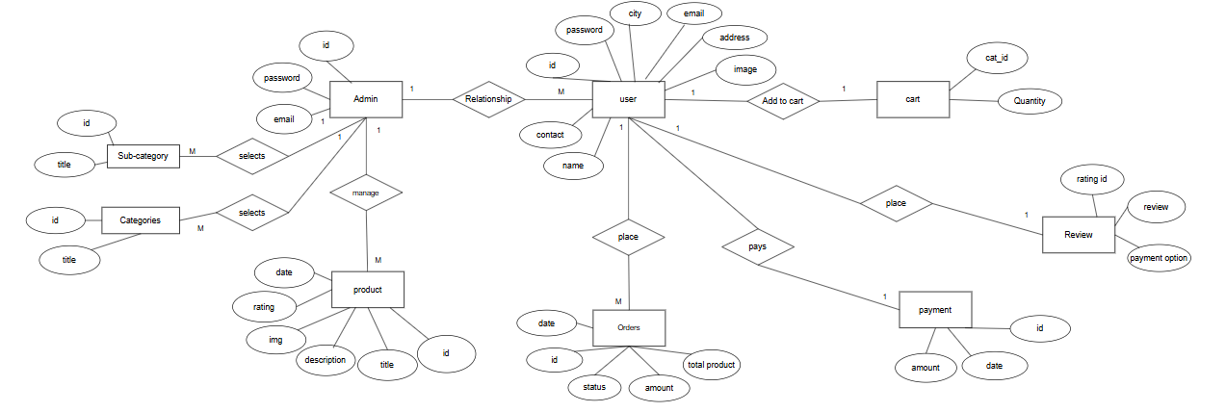
Fig. Entity Relation Diagram

3.1.4. Process Modeling (DFD)

A data flow diagram (DFD) maps out the flow of information for any processor system. It uses defined symbols like rectangles, circles and arrows, plus short text labels, to show data inputs, outputs, storage points and the routes between each destination. Data flowcharts can range from simple, even hand-drawn process overviews, to in-depth, multi-level DFDs that dig progressively deeper into how the data is handled. They can be used to analyze an existing system or model a new one.

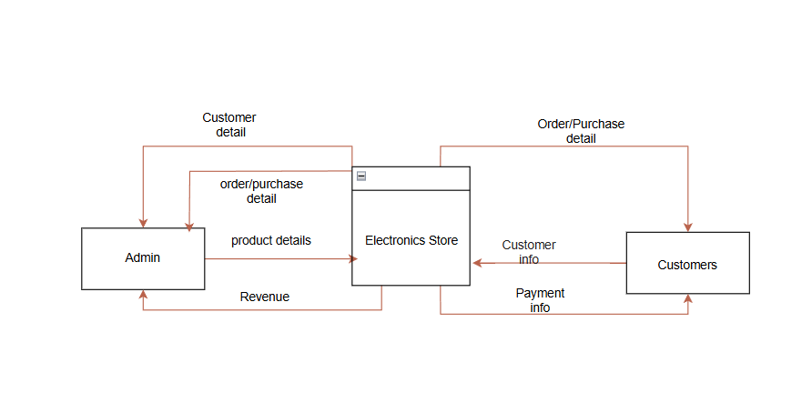

Fig. Level 0 DFD

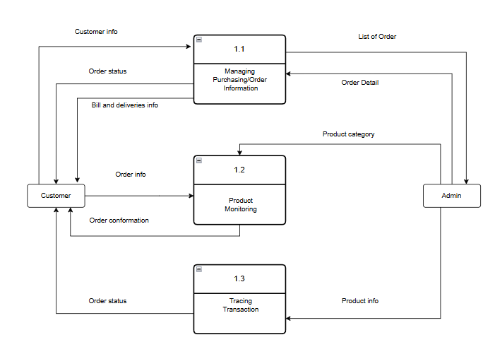

Fig. Level 1 DFD of Electronics Store

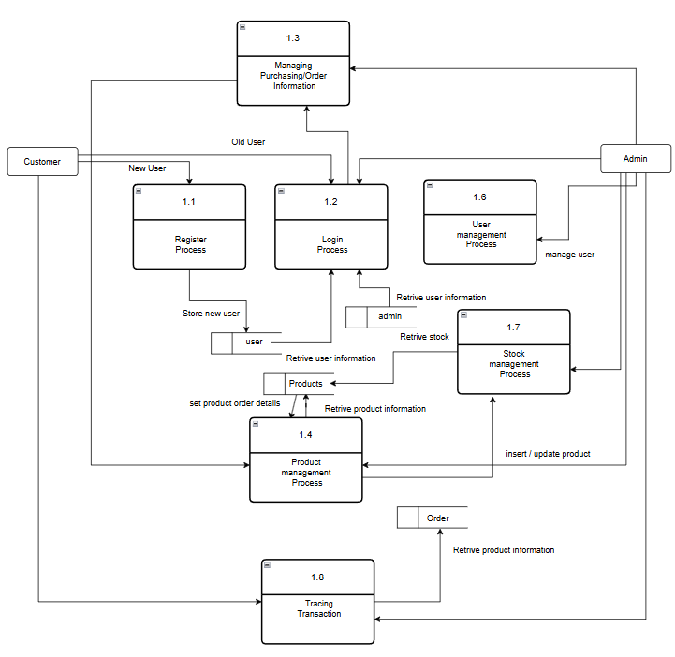
Fig. Level 2 DFD of Electronics Store

3.2. System Design
The system design defines how the e-commerce platform operates internally and how its components interact. The goal is to create a robust, scalable, and user-friendly platform for selling electronics online.

3.2.1. Architectural Design

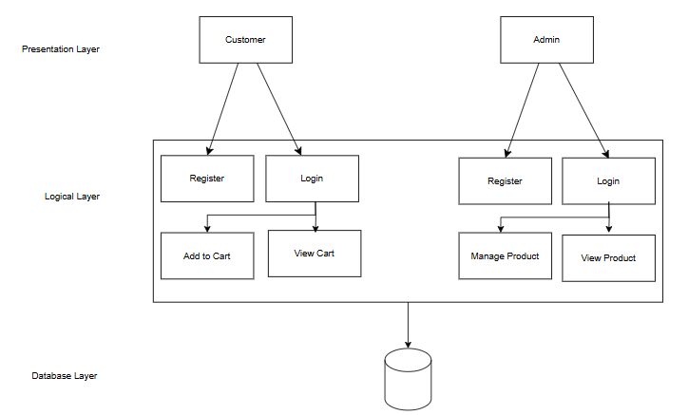

Fig. Architectural Design

Presentation layer defines the overall architecture of the Electronics Store (E-commerce), including its components, modules, and interactions. It uses 3-tier architecture consisting of Presentation,Business(logical) and Database layer Users interact through a simple interface, and their data is stored in a database.The system manages transactions using multiple tables, each with specific attributes, and assigns unique account numbers to users. Each layer operates independently, offering flexibility and scalability.

3.2.2. Database Schema Design

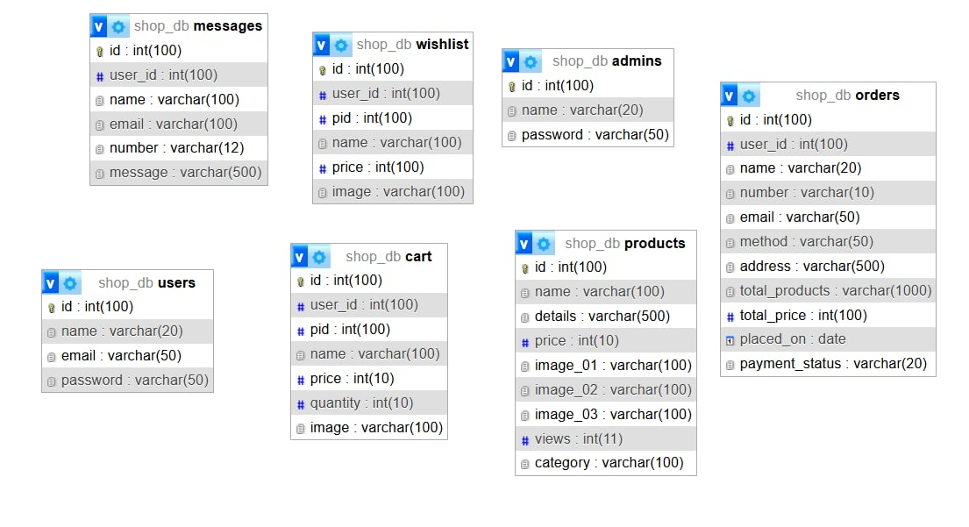

Fig. Database Schema Design

3.2.3. Interface Design (UI Interface/ Interface Structure Diagrams)
User interface design or user interface engineering is the design of user interfaces for machines and software.The interface is intended to be simple and intuitive. Here is some of screen shots of our user system interface.

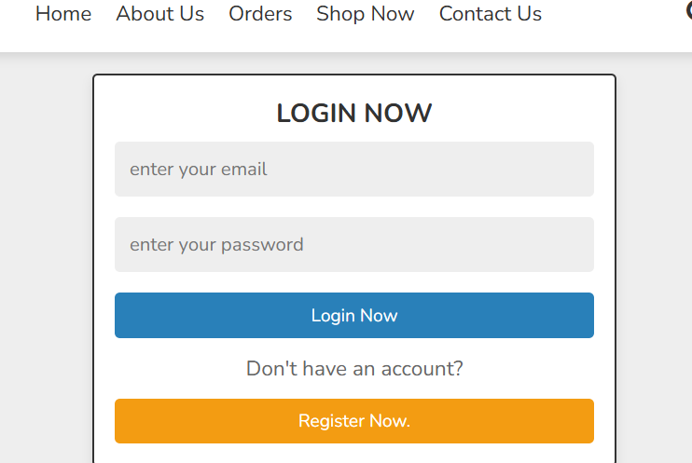

Fig. User Login

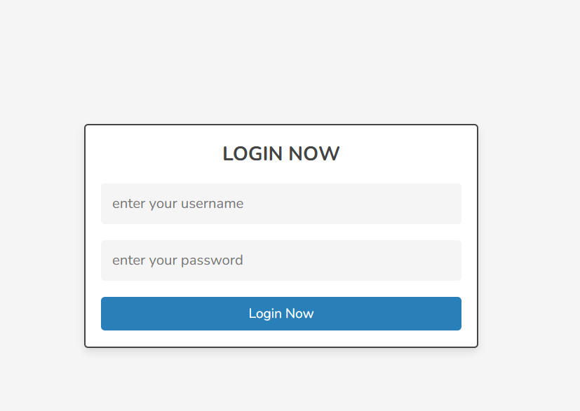

Fig. Admin Login



Fig. User Register

3.3 Algorithm details

1. Personalized Product Recommendation
Algorithm Logic: Instead of recommending random or latest products, this algorithm analyzes the user's personal interests by looking at the categories of products they have added to their wishlist and cart.
It then recommends products from those categories, ensuring the suggestions are relevant to the user's shopping behavior.
Steps:
- Fetch all distinct categories from the user's wishlist and cart.
- Merge and deduplicate the category list.
- Select products from these categories, limiting the results to 6.
- Display the recommended products to the user.
Result: This approach increases the likelihood that recommended products match the user's preferences, leading to a more personalized shopping experience and higher engagement.

2. Most Viewed Products
Purpose:
Displays the Top 5 products based on the number of times they have been viewed.
How it Works:
Each time a product detail page is visited, the view count is increased by one:
product.viewCount += 1;
await product.save();
Products are then sorted by view count in descending order to find the top 5 most viewed
products.
3. Related Products
Logic:
Displays similar products based on the same category and sub-category, excluding the
product currently being viewed.

Chapter 4: CONCLUSION

4.1. Conclusion

The Electronics Store E-commerce project successfully provides a digital platform for customers to browse, select, and purchase electronic products conveniently. By implementing user-friendly navigation, secure payment gateways, and an organized product catalog, the system enhances customer satisfaction and streamlines the purchasing process. The project demonstrates that online platforms can significantly improve sales efficiency, reduce operational costs, and expand the store’s reach beyond local boundaries. Overall, this project contributes to modernizing retail operations and adapting to the growing trend of digital commerce.

4.2. Future Recommendations

- Mobile Application Development: Develop a dedicated mobile app to improve accessibility and user engagement.
- AI-Powered Recommendations: Implement artificial intelligence for personalized product suggestions based on user behavior.
- Advanced Analytics: Integrate analytics tools to monitor customer preferences, sales trends, and inventory management.
- Enhanced Security: Incorporate two-factor authentication and SSL certifications to strengthen data protection.
- Multi-Vendor Marketplace: Expand the platform to allow multiple vendors, increasing product variety and competitive pricing.
- Customer Support Automation: Use chatbots or AI assistants to provide instant support and improve customer service.
- AR/VR Features: Introduce augmented or virtual reality features for customers to experience products virtually before purchase.

References

- · Laudon, K. C., & Traver, C. G. (2020). E-commerce 2020: Business, Technology, Society. Pearson.
- · Chaffey, D. (2019). Digital Business and E-Commerce Management. Pearson Education.
- · Turban, E., King, D., Lee, J., Liang, T.-P., & Turban, D. (2018). Electronic Commerce 2018: A Managerial and Social Networks Perspective. Springer.
- · Research articles and journals on e-commerce technologies, online payment security, and user interface design.
- · Official documentation of technologies used in the project (e.g., PHP, MySQL, HTML, CSS, JavaScript).
·

